Edwin Ng

**Big Mountain Resort:**

Using Models to Reimagine Resort Ticket Pricing

horizontal line

# 

# Introduction

Big Mountain Resort is a ski resort located in Montana that boasts 105 trails and hosts about 350,000 people skiers and snowboarders each year. They recently spent $1.54 million dollars to install a new chair lift to better distribute their guests throughout the park. The resort management feel as though they have not been capitalizing on their facilities as much as they could have. Previous ticket pricing strategies were simply based on charging above average prices across resorts. This strategy is limited in that the resort does not know if this price point is driving customers away or if they could be charging more for what they offer. The resort needs another method to price their tickets such that they can maximize their profits while staying competitive.With the limitations of our current pricing strategy, the question then becomes how? How can Big Mountain Ski Resort adjust its ticket pricing based on facility composition relative to other ski resorts such that they can recover the $1.54 million investment cost in revenue over a span of 3 years while still remaining competitive in their pricing?

### Methodology

Our process came in three distinct phases. First came the exploratory data analysis. Just from poking around the data, we were able to quickly see where Big Mountain resort ranks amongst its competitors - quite highly. While it was amongst the best in many features, we noticed that several components were responsible for most of the deviations in ticket prices, telling us that there are some features at resorts that play a larger role in ticket pricing than others. This leads us to our next phase, data preprocessing and model training. From the results of our previous work, we went about creating a model trained on our dataset that could help us understand which features were the most important. We tested two different mathematical models - the linear regression model and the random forest model. We decided to move forward with the random forest model because even though the models predicted the same features - fastQuads, Runs, snow making_ac, and vertical drop - the random forest regression model performed more consistently and with a lower margin of error. Finally, we reached the last phase of our data analysis. After training the model and understanding which features were the most important, we used our models to predict the adult weekend ticket price for Big Mountain resort based on where our resort ranked amongst its competitors in terms of important features such as fast quads, number of runs, and total snow making area. On top of this we used our model to model the effects of various scenarios on ticket prices.

**Findings**

As of right now, Big Mountain resort currently charges $81.00 for its adult weekend tickets. **On the contrary, our model suggests that Big Mountain resort’s facilities could support a price of $95.87.** The figure below illustrates where we currently stand amongst our competitors in terms of adult weekend ticket price:

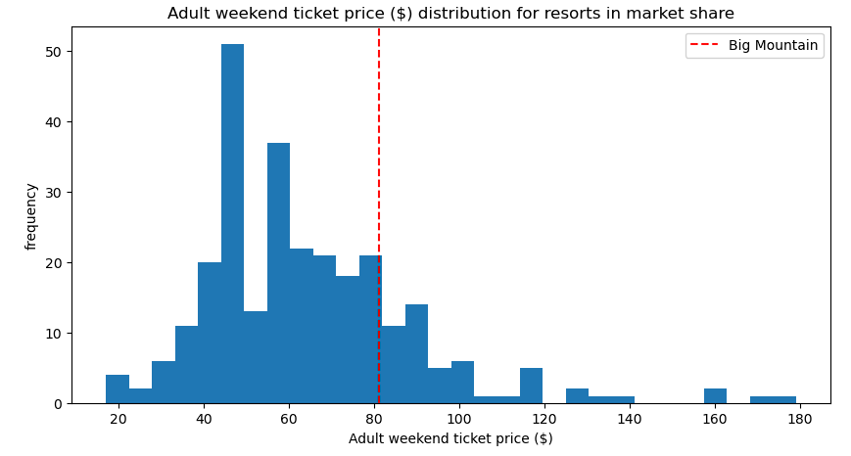

While the discrepancy between our current price and our model’s prediction might come at a surprise, this is because we had just been basing our resorts ticket prices on the average of our competitors and charging a premium relative to that metric. The problem with this approach, however, is that unlike our model, this method fails to take into account the importance of each individual feature and adjust our price point based on how high we rank in that category. Some of the most important features include fast quads, runs, and snow making area - all of which Big Mountain Resort ranks amongst some of the highest. For example, when it comes to fast quads, the vast majority of resorts have none whereas Big Mountain Resort has 3, and only a handful of resorts have more.

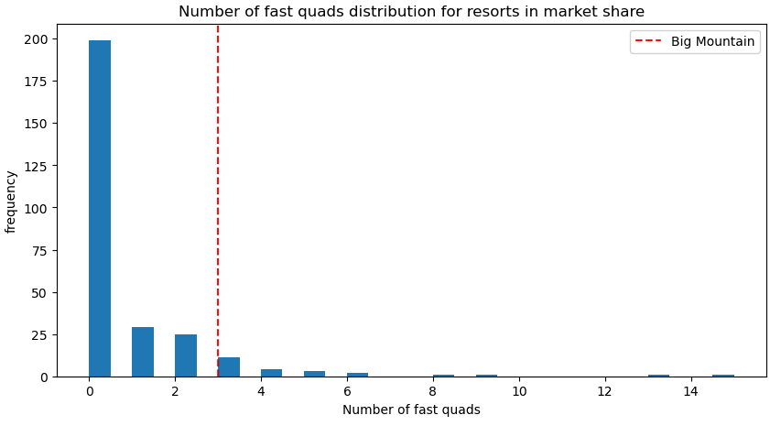

As for the various scenarios suggested by management, here are our recommendations:

**Increasing revenue by increasing the resort’s vertical drop by creating a new run and installing a new chairlift:** Our model suggests that doing so would support further increasing ticket prices by up to $8.61 which would in turn increase our overall seasonal revenue by $15065471.

**Increasing revenue by adding 2 Acres of Snow on top of installing a new chairlift, or increasing the longest run by 0.2 miles:** Our model indicates that either scenario would not produce a significant difference in price increase relative to the first scenario. Our results show that the first course of action would support an increase of less than $2 - which would barely increase our revenue. On the other hand, increasing the longest run by 0.2 miles would not lead to any increase in revenue at all since this feature is so unimportant when it comes to ticket prices. Due to the amount of work and financial investment that it would take to produce these results, we would not recommend either of these plans since the returns would not make it worth our while.

**Increasing revenue by cutting costs by shutting down up to 10 runs:**

Our model suggests that shutting down any number of runs would lead to a decrease in ticket price. That being said, it would not be a completely horrible idea since it would also help to reduce maintenance and staffing costs for the resort. As such we had our model predict the decrease in ticket price based on the number of runs closed:

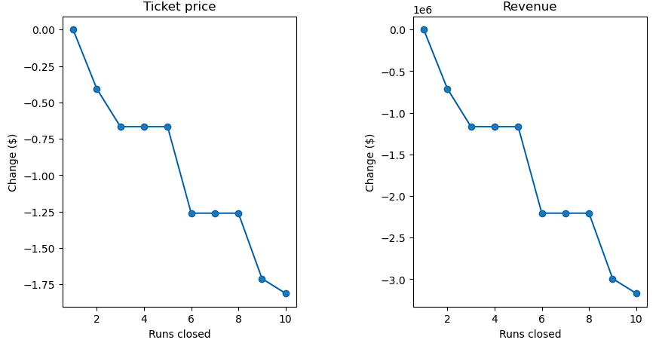

As you can see from our graphs above, closing 5 runs would be the optimal number because the difference in closing 2 and 3 runs is not that large. On top of this, there is no difference in ticket price whether you close down 3 runs or 5 runs. However, any more than 5 closures results in drastic drops in revenue.

**Recommendations**

Overall, I would recommend a combination of the following actions. At a very base level, I would recommend increasing our base adult weekend ticket price by a minimum of $5 up to up to a per-ticket price of $95.87. This would drastically improve resort revenue and does not require any further modifications to the resort as this is what our model predicts that the resort could currently support. On top of this, increasing the vertical drop of our resort by 150 feet and installing an additional chair lift would support a further increase in ticket price of up to $8.61 - further increasing our revenue. Finally, we could look to close down 5 of our most unpopular runs. While this might decrease our ticket price a little bit, it would save the resort money in terms of maintenance, equipment, and staffing costs.